**Assignment-2**

**Ambati Sai Aravind**

**16336124**

By Using the given data set we obtained the following results

From the given data set

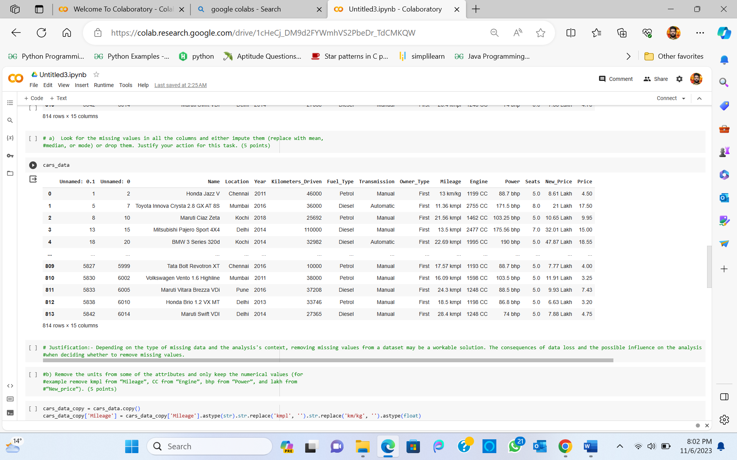

b)

c)

d)

